**A**

**PROJECT REPORT**

**ON**

**“****CAREEXPERT”**

**Submitted by,**

**Miss. : Varale Shruti Bhausaheb**

**Miss. : Roham Christina Prashant**

**Mr. : Kadam Amol Ramesh**

**Mr. : Gaikwad Dipak Kashinath**

**In partial fulfilment of the award of the degree of**

**B.C.A (Computer Science) (SEM VI)**

**Of**

**Sangamner Nagarpalika Arts, D.J. Malpani Commerce & B.N. Sarda Science College (Autonomous) , Sangamner**



**SHIKSHAN PRASARAK SANSTHA’S** Ph. (02425) 225893 (0)

SANGAMNER NAGARPALIKA ARTS, Resi- 225164 (R)

D.J. MALPANI COMMERCE & Fax – (02425) 225893

B.N. SARDA SCIENCE COLLEGE(Autonomous) (Id No. PU/AN/ASC/03/1961)

SANGAMNER-422605 Dist –A. NAGAR•NAAC Re-accredited College (A+ Grade)

“Spread knowledge unto the last” • Pune University Best College

E-mail: –info@sangamnercollege.edu.in Best College Award 2002-03

Web: [www.sangamnercollege.edu.in](http://www.sangamnercollege.edu.in/) • DBT Star College, DST-FIST

Date: / /

***CERTIFICATE***

This is to certify that,

Mr./Miss. _________________________ has completed the project on_____________________________________ as a partial fulfilment of

B.C.A. **Science) (SEM VI)** laid down by the autonomous college affiliated to Savitribai Phule Pune University, satisfactorily during the academic Year

2022-2023.

***Project Guide* *Head of the Department***

***Internal Examiner External Examiner***

**INDEX**

|  |  |
| --- | --- |
| **Sr. No.** | **Title** |
| **1** | **Introduction** |
| **2** | **Scope** |
| **3** | **ER Diagram** |
| **4** | **Database** |
| **5** | **Code** |
| **6** | **Output Screen** |
| **7** | **Report** |
| **8** | **Future Enhancement** |
| **9** | **Bibliography** |

1. **INTRODUCTION**

* The field of study in medical analysis. Significant efforts have been made in recent years to develop computer application.
* Where user entered all vitals sign related to the patient using many pre-defined options.
* Application design on for the particular need of the user carry out health examination smooth and effective manner.
* This application can use to reduce human error as much possible in the field of medical science.
* No formal knowledge is needed for the user to use the system.
* Care expert web application is as describe above, can lead to safe, secure, reliable and precise system.

**2.SCOPE OF SYSTEM**

CareExpert is a web Application which provide complete health care system providing the end-user with a responsive User Interface, wherein the user can enter all the vitals signs related to the patient using many predefined options. Moreover, this application is designed for the particular need of the user to carry out health examinations in a smooth and effective manner. This application can be used to reduce human error as much as possible in the field of medical science. No formal knowledge is needed for the user to use this system.

* The project is basically targeted to provide health related services to remote places and provide better health care and improve national health
* Citizens can be instantly examined using this system which will be available to doctors, sevika, NGO, screeners, etc.
* This will provide proper diagnosis, maintain medical records and will be easily available to all.
* Past medical records and treatment processes will prove helpful in case a citizen migrates or consult another doctor.
* Digital prescriptions will be generated that will eliminate false prescriptions and irregularities in the pharmaceuticals.
* Thus the national health will be in good hands as CareExpert will provide the best health care, provide fast and reliable health services, eliminate irregularities and form a strong foundation for a healthy nation.

**3.ER-DIGRAM**

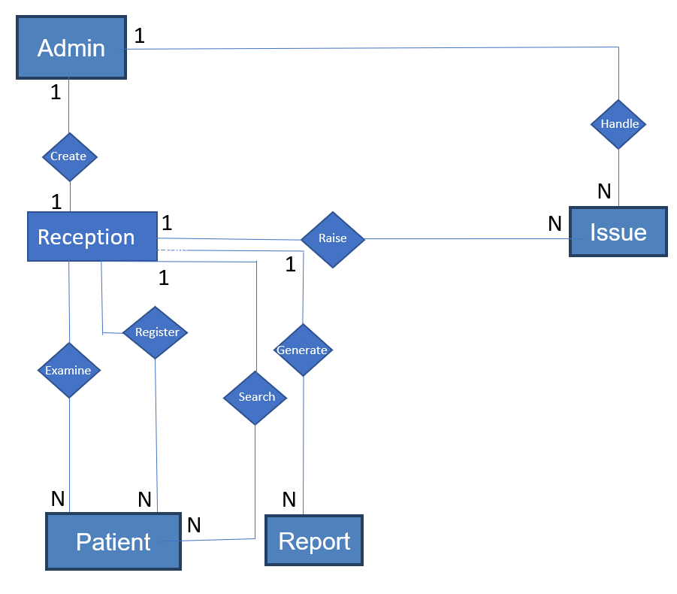

*FIG. 2.1 ER DIAGRAM*

**4.DATABASE**

# TABLES

* + - **User Table**

|  |  |  |  |
| --- | --- | --- | --- |
| **Field** | **Type** | **Description** | **Constraints** |
| ID | IntegerField | ID of the user. | Primary Key |
| mobile | IntegerField | mobile of the user. | NOT NULL |
| specialization | CharField(20) | specialization of the user. | NOT NULL |
| gender | CharField(20) | gender of the user. | NOT NULL |
| qualification | CharField(20) | qualification of the user. | NOT NULL |
| dob | DateField | dob of the user. | NOT NULL |
| blood_grp | CharField(20) | blood_grp of the user. | NOT NULL |
| country | CharField(20) | country of the user. | NOT NULL |
| state | CharField(20) | state of the user. | NOT NULL |
| district | CharField(20) | district of the user. | NOT NULL |
| address | CharField(20) | address of the user. | NOT NULL |
| aadhar | CharField(20) | aadhar of the user. | NOT NULL |
| pincode | CharField(20) | pincode of the user. | NOT NULL |

# Symptoms Table

|  |  |  |  |
| --- | --- | --- | --- |
| Field | Type | Description | Constraints |
| symptoms | CharField(20) | symptoms of the user. | NOT NULL |
| height | CharField(20) | height of the user. | NOT NULL |
| weight | CharField(20) | weight of the user. | NOT NULL |

|  |  |  |  |
| --- | --- | --- | --- |
| spo2 | CharField(20) | spo2 of the user. | NOT NULL |
| pulse | CharField(20) | pulse of the user. | NOT NULL |
| temp | CharField(20) | temp of the user. | NOT NULL |
| arm | CharField(20) | arm of the user. | NOT NULL |

* + - **Admin Table**

|  |  |  |  |
| --- | --- | --- | --- |
| **Field** | **Type** | **Description** | **Constraints** |
| Username | CharField(20) | username of the user | NOT NULL |
| Password | CharField(20) | password of the user | NOT NULL |
| Email | email | email of the user | NOT NULL |

# Survey Table

|  |  |  |  |
| --- | --- | --- | --- |
| **Field** | **Type** | **Description** | **Constraints** |
| Add Family Members | TextField | Add the family members | NOT NULL |
| No of Family Members | IntegerField | No. of Family members | NOT NULL |
| Name of head of family | CharField(20) | Name of head of family | NOT NULL |
| No of other adult males | IntegerField | No of other adult males | NOT NULL |
| No of other adult Females | IntegerField | No of other adult Females | NOT NULL |
| No of male children | IntegerField | No of male children | NOT NULL |
| No of female children | IntegerField | No of female children | NOT NULL |
| select_family | CharField(50) | Select the family | NOT NULL |
| water_source | CharField(20) | Drinking water Source of Users | NOT NULL |

|  |  |  |  |
| --- | --- | --- | --- |
| water_requiring_treatment | CharField(20) | Drinking water requiring treatment | NOT NULL |
| non_usage_of_toilets | CharField(20) | Non usage of toilets | NOT NULL |
| distance_of_subcenters | CharField(20) | Distance of Subcenters from users home | NOT NULL |
| distance_of_primary_healt h_centers | CharField(20) | Distance of Primary Health Centers from users home | NOT NULL |
| distance_of_community_h ealth_centers | CharField(20) | Distance of Community Health Centers from users home | NOT NULL |
| distance_of_district_hospit als | CharField(20) | Distance of District Hospitals from users home | NOT NULL |
| distance_of_pathology_lab | CharField(20) | Distance of pathology lab from users home | NOT NULL |
| distance_of_medical_store | CharField(20) | Distance of Medical Store from users | NOT NULL |
| status_of_delivery_of_chil dren | CharField(50) | Status of delivery of children | NOT NULL |
| status_of_vaccination_of_ children | CharField(20) | Status of vaccination of children | NOT NULL |
| status_of_female_related_ problems | CharField(20) | Status of female related problems | NOT NULL |
| centrally_issued_health_in surance | CharField(20) | Centrally Issued health insurance | NOT NULL |
| state_issued_health_insura nce | CharField(20) | State Issued health insurance | NOT NULL |
| personal_health_insurance | CharField(20) | Personal health insurance | NOT NULL |

1. **CODE**
2. LOGIN PAGE CODE:

{% load static %}

<!DOCTYPE html>

<html lang="en">

<head>

<meta charset="utf-8">

<meta name="viewport" content="width=device-width, initial-scale=1">

<title>DiagnoseIndia</title>

<meta name="description" content="Free Bootstrap Theme by BootstrapMade.com">

<meta name="keywords" content="free website templates, free bootstrap themes, free template, free bootstrap, free website template">

<link rel="stylesheet" type="text/css" href="https://fonts.googleapis.com/css?family=Open+Sans|Raleway|Candal">

<link rel="stylesheet" type="text/css" href="{% static 'home/css/font-awesome.min.css' %}">

<link rel="stylesheet" type="text/css" href="{% static 'home/css/bootstrap.min.css' %}">

<link rel="stylesheet" type="text/css" href="{% static 'home/css/style.css' %}">

</head>

</div>

<body id="myPage" data-spy="scroll" data-target=".navbar" data-offset="60">

<section id="banner" class="banner">

<div class="bg-color">

<div class="container">

<div class="row">

<div class="banner-info" >

<section id="cta-2" class="section-padding" style="width: 500px; height:350px; padding:50px; padding-top:10px; text-align:center;">

<div class="container" >

<div class=" row">

<div class="col-md-2"></div>

<section id="contact" class="section-padding" >

<div class="container">

<div class="row">

1. DASHBOARD PAGE CODE:

{% extends 'adminbase.html' %}

{% load widget_tweaks %}

{% block content %}

<head>

<meta charset="utf-8">

<meta name="viewport" content="width=device-width, initial-scale=1, shrink-to-fit=no">

<meta name="viewport" content="width=device-width, initial-scale=1">

<script src="https://ajax.googleapis.com/ajax/libs/jquery/1.10.2/jquery.min.js"></script>

<link href="http://netdna.bootstrapcdn.com/bootstrap/4.0.0-beta/css/bootstrap.min.css" rel="stylesheet">

<link rel="stylesheet" href="https://maxcdn.bootstrapcdn.com/bootstrap/4.4.1/css/bootstrap.min.css">

<link href="https://maxcdn.bootstrapcdn.com/font-awesome/4.3.0/css/font-awesome.min.css" rel="stylesheet">

<style type="text/css">

a:link {

text-decoration: none;

}

.order-card {

color: rgb(255, 255, 255);

}

.bg-c-blue {

background: #04868f;

}

1. REPORT:

{% load static %}

<!DOCTYPE html>

<html lang="en">

<head>

<meta charset="UTF-8">

<meta http-equiv="X-UA-Compatible" content="IE=edge">

<meta name="viewport" content="width=device-width, initial-scale=1.0">

<title>Report</title>

<!-- CSS only -->

<link href="https://cdn.jsdelivr.net/npm/bootstrap@5.1.3/dist/css/bootstrap.min.css" rel="stylesheet" integrity="sha384-1BmE4kWBq78iYhFldvKuhfTAU6auU8tT94WrHftjDbrCEXSU1oBoqyl2QvZ6jIW3" crossorigin="anonymous">

<!-- JavaScript Bundle with Popper -->

<script src="https://cdn.jsdelivr.net/npm/bootstrap@5.1.3/dist/js/bootstrap.bundle.min.js" integrity="sha384-ka7Sk0Gln4gmtz2MlQnikT1wXgYsOg+OMhuP+IlRH9sENBO0LRn5q+8nbTov4+1p" crossorigin="anonymous"></script>

<link rel="stylesheet" href="{% static 'instant_exam/style1.css' %}">

</head>

<body>

<div class="container bootdey">

<div class="row invoice row-printable">

<div class="col-md-10">

<!-- col-lg-12 start here -->

<div class="panel panel-default plain" id="dash_0">

<!-- Start .panel -->

<div class="panel-body p30">

<div class="row">

<!-- Start .row -->

1. Register:

<body >

<section class="img" onload="resetSelection()" style="background-image: url({% static 'register/images/health1.jpg'%}); width:100%;">

<div class="bg-color p-t-180 p-b-100 font-robo ftco-section" >

<div class="">

<div class="container">

<!--form method="POST">

{% csrf_token %--}

<--body onload="resetSelection()"-->

<div class="row justify-content-center">

<div class="col-md-4 text-center mb-4">

<h2 class="heading-section">Registration form</h2>

</div>

</div>

<div class="row justify-content-center">

<div class="col-md-3 col-lg-6">

<div class="login-wrap">

<h3 class="text-center mb-4">Create Your Account</h3>

<form action="" method="POST" class="signup-form" enctype="multipart/form-data">

{% csrf_token %}

<div class="form-group mb-2">

<label class="first_name" for="first_name">first Name</label>

<input type="text" id="first_name" name="first_name" class="form-control" placeholder="Enter first name" required=""

<span class="icon fa fa-user-o"></span>

</div>

<div class="form-group mb-2">

<label class="last_name" for="last_name">last name</label>

<input type="text" id="last_name" name="last_name" class="form-control" placeholder="Enter last name" required="" />

<span class="icon fa fa-user-o"></span>

</div>

1. PROFILE:

{% load static %}

<html lang="en">

<head>

<meta charset="UTF-8">

<meta name="viewport" content="width=device-width, initial-scale=1, shrink-to-fit=no">

<meta name="description" content="Colorlib Templates">

<meta http-equiv="X-UA-Compatible" content="IE=edge">

<meta name="author" content="Colorlib">

<meta name="keywords" content="Colorlib Templates">

<!-- CSS only -->

<link href="https://cdn.jsdelivr.net/npm/bootstrap@5.1.3/dist/css/bootstrap.min.css" rel="stylesheet" integrity="sha384-1BmE4kWBq78iYhFldvKuhfTAU6auU8tT94WrHftjDbrCEXSU1oBoqyl2QvZ6jIW3" crossorigin="anonymous">

<!-- JavaScript Bundle with Popper -->

<script src="https://cdn.jsdelivr.net/npm/bootstrap@5.1.3/dist/js/bootstrap.bundle.min.js" integrity="sha384-ka7Sk0Gln4gmtz2MlQnikT1wXgYsOg+OMhuP+IlRH9sENBO0LRn5q+8nbTov4+1p" crossorigin="anonymous"></script>

<!-- Icons font CSS-->

<link href="{% static 'instant_exam/vendor/mdi-font/css/material-design-iconic-font.min.css' %}" rel="stylesheet" media="all">

<link href="{% static 'instant_exam/vendor/font-awesome-4.7/css/font-awesome.min.css' %}" rel="stylesheet" media="all">

<!-- Font special for pages-->

<link href="https://fonts.googleapis.com/css?family=Roboto:100,100i,300,300i,400,400i,500,500i,700,700i,900,900i" rel="stylesheet">

1. Views:

import numpy as np

import pandas as pd

from scipy.stats import mode

# import matplotlib.pyplot as plt

# import seaborn as sns

from sklearn.preprocessing import LabelEncoder

from sklearn.model_selection import train_test_split, cross_val_score

from sklearn.svm import SVC

from sklearn.naive_bayes import GaussianNB

from sklearn.ensemble import RandomForestClassifier

from sklearn.metrics import accuracy_score, confusion_matrix

from datetime import date

today=date.today()

d1=today.strftime("%A, %B %d, %Y")

# Create your views here.

def index(request):

return render(request,'index.html')

def dashboard(request):

return render(request,'admin_dashboard.html')

def sendEmail(to, content):

server = smtplib.SMTP('smtp.gmail.com', 587)

server.ehlo()

server.starttls()

server.login('dipakgaikwadmg@gmail.com', 'uhbfgvgbyvmadnvk')

server.sendmail('dipakgaikwadmg@gmail.com', 'dipakgaikwadmg@gmail.com')

server.close()

def user_login(request):

if request.method=='POST':

username=request.POST['username']

password=request.POST['password']

user = auth.authenticate(username=username,password=password)

if user is not None:

auth.login(request,user)

return redirect(reverse('home:dashboard'))

else:

print('admin login error')

return redirect(reverse('home:user_login'))

else:

return render(request, 'user_login.html')

**6. INPUT SCREEN**

1. LOGIN PAGE :

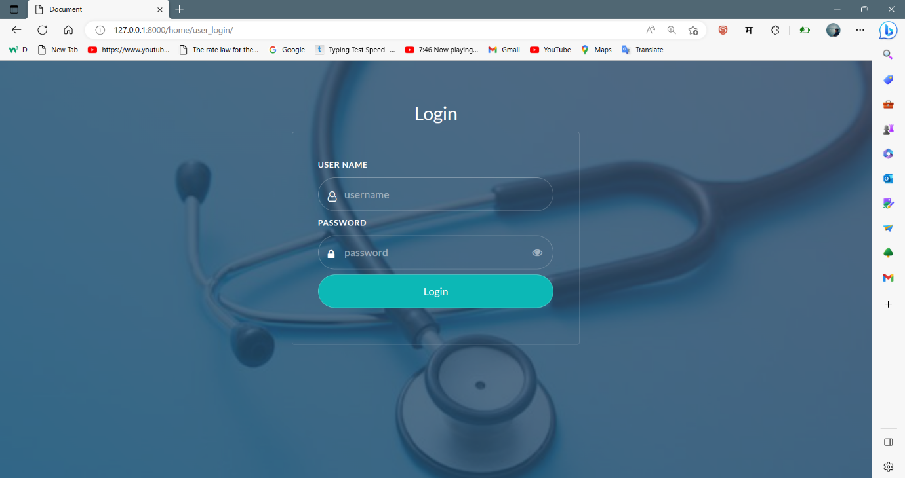

1. DASHBOARD :

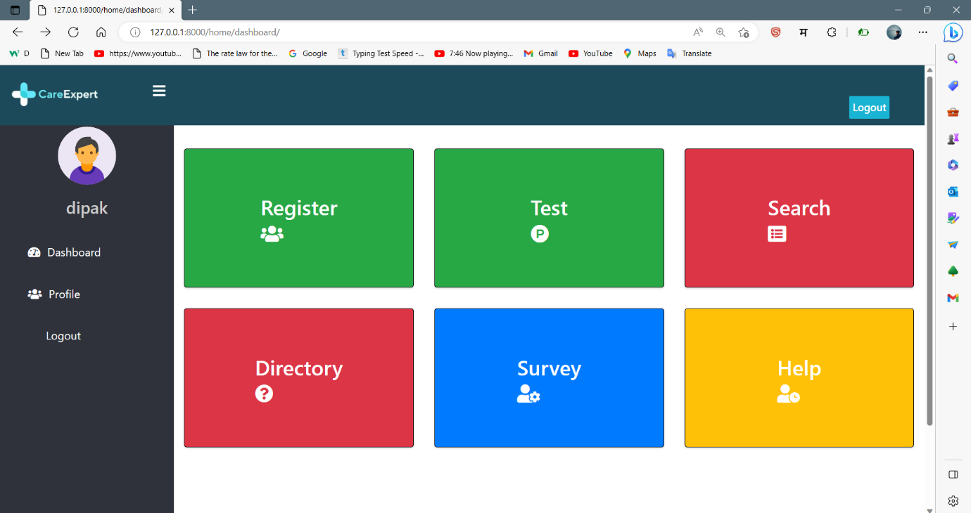

PATIENT REGISTRATION :

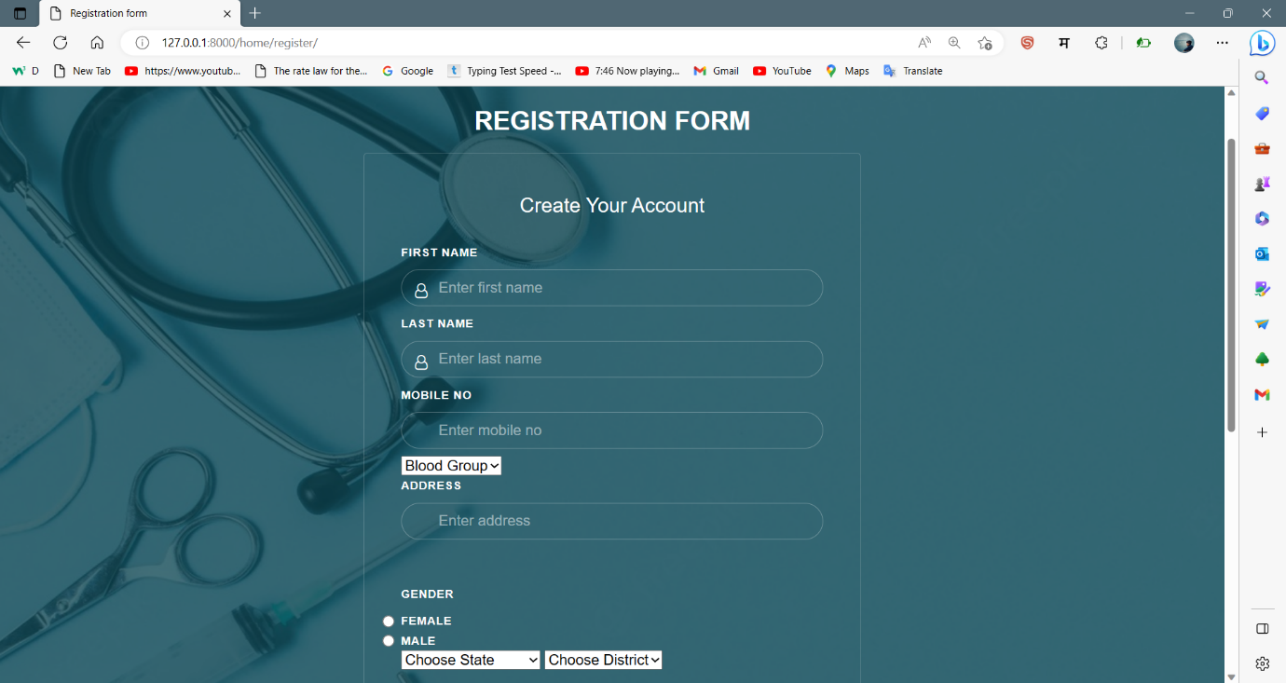

1. PATIENT INFORMATION :

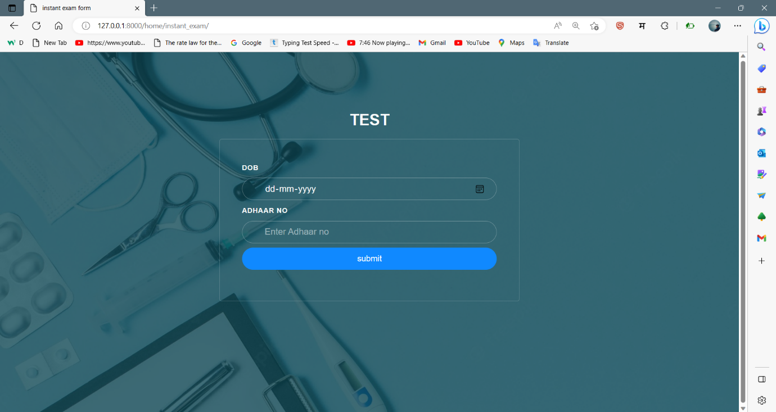

1. VITALS :

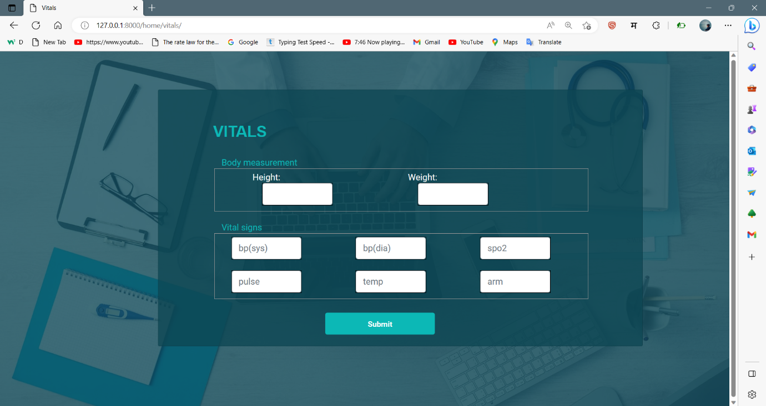

1. SYMPTOMS :

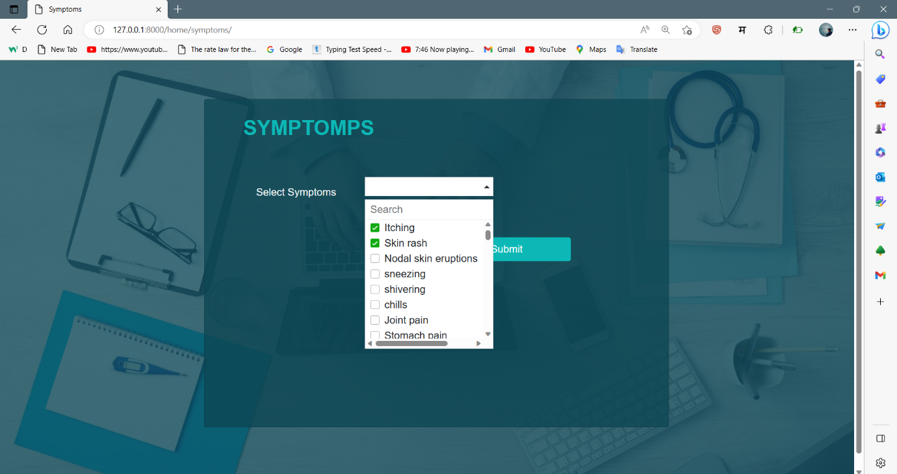

**7. OUTPUT SCREEN**

1. SEARCH PATIENT :

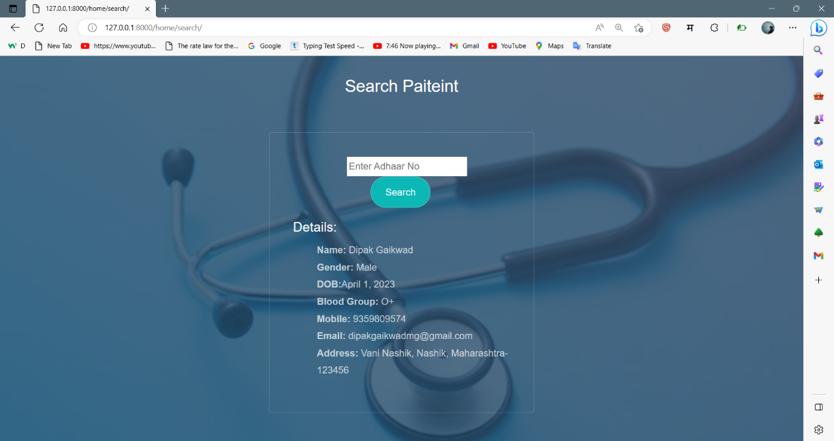

2. REPORT

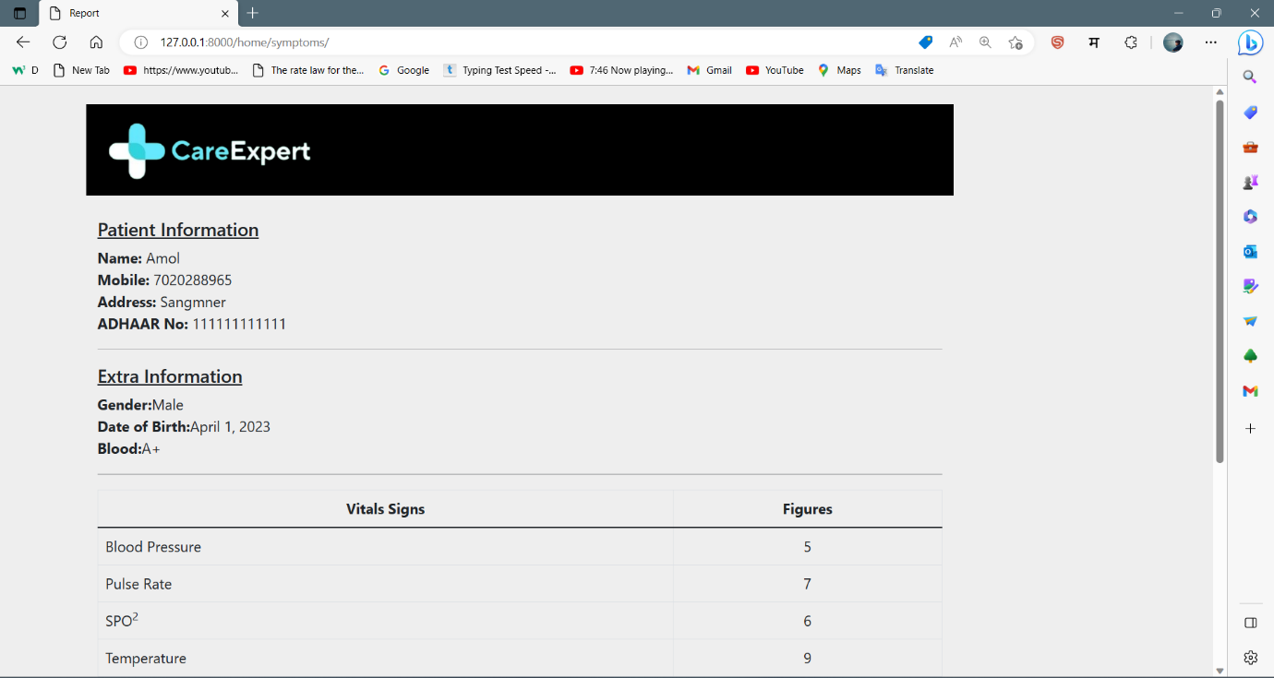

3. PREDICTION :

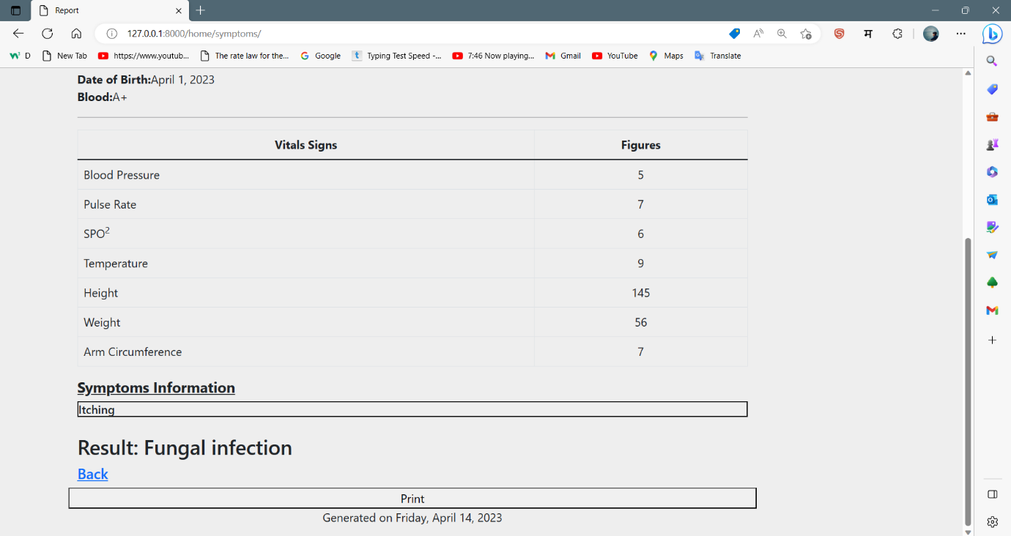

4. AFTER REGISTRATION :

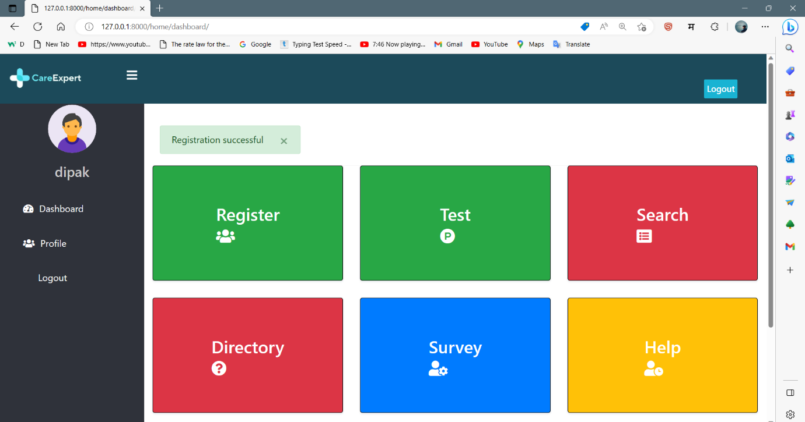

**REPORTS**

**Report No : 1**

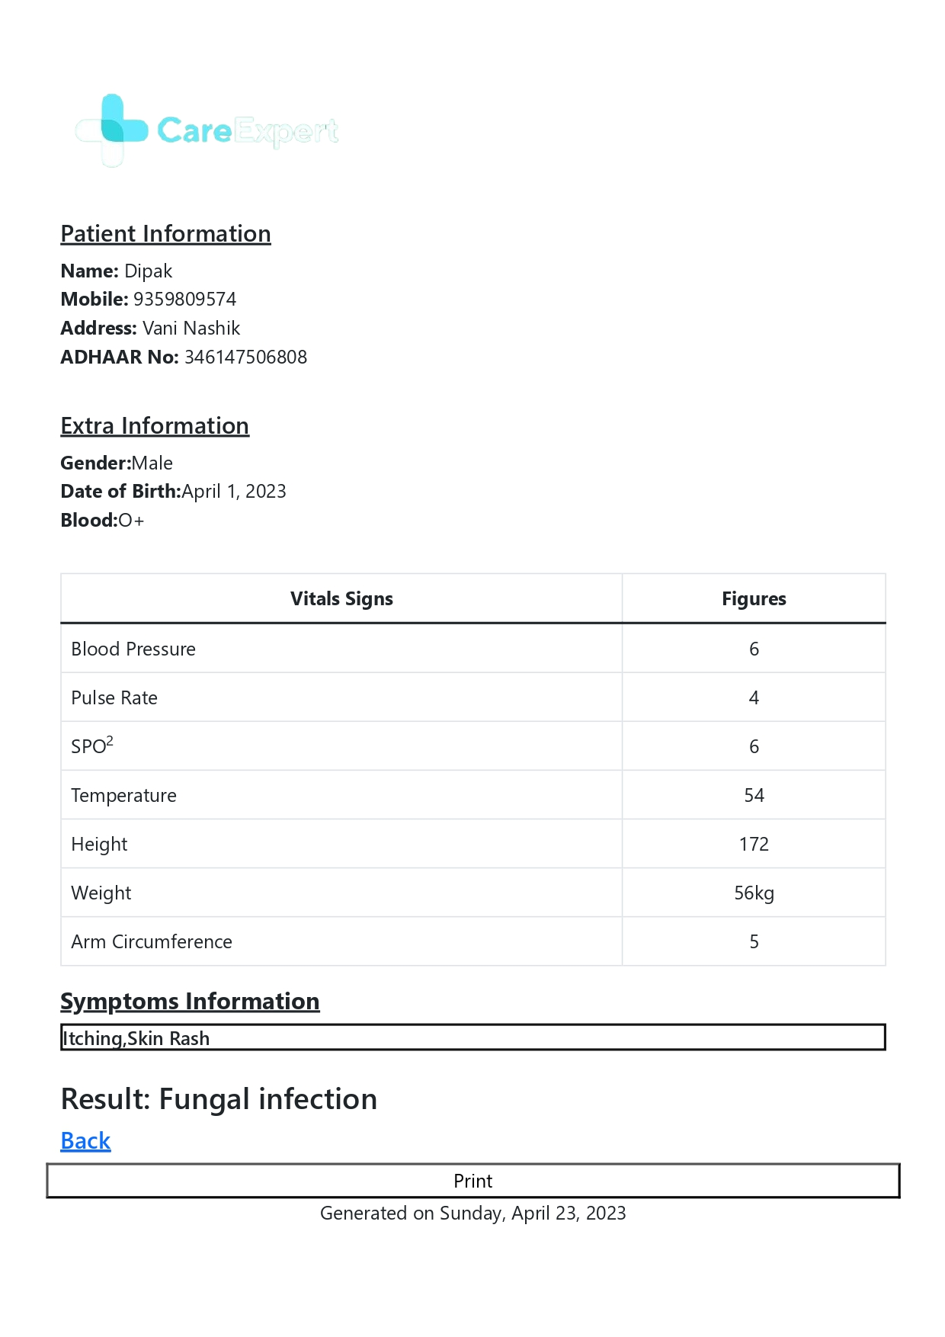

**Report No: 2**

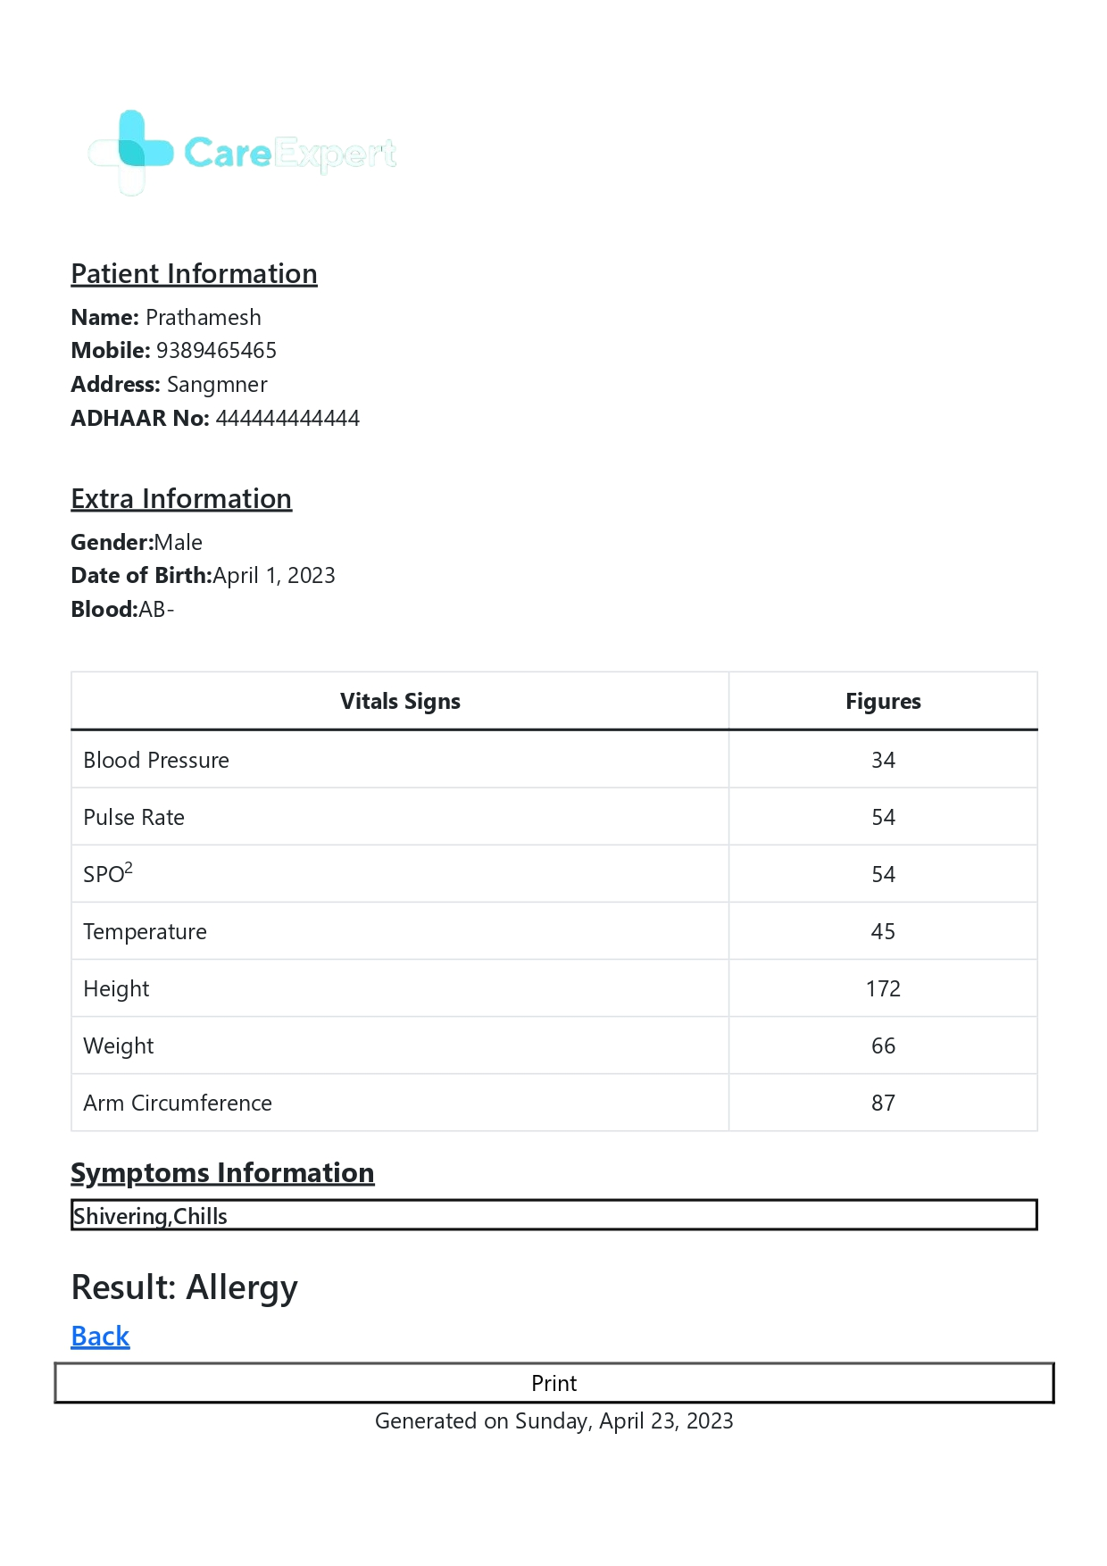

**Report No: 3**

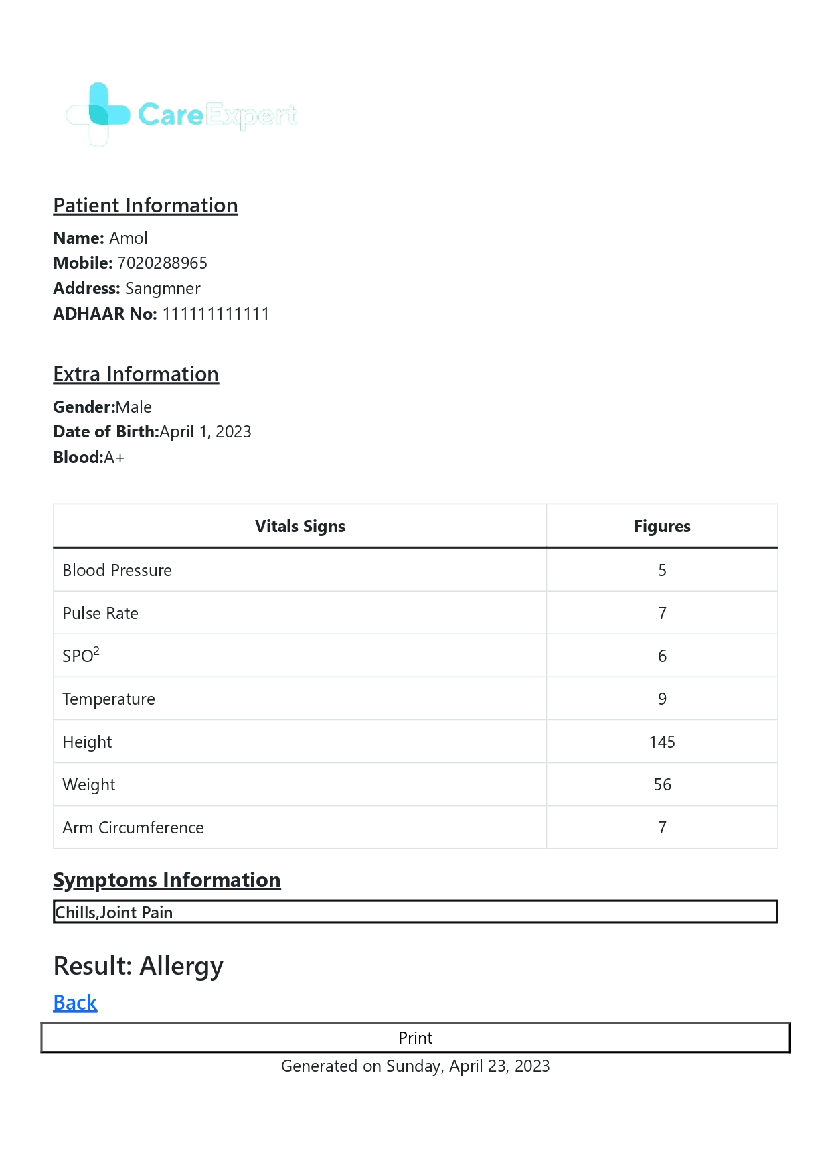

**Report No: 4**

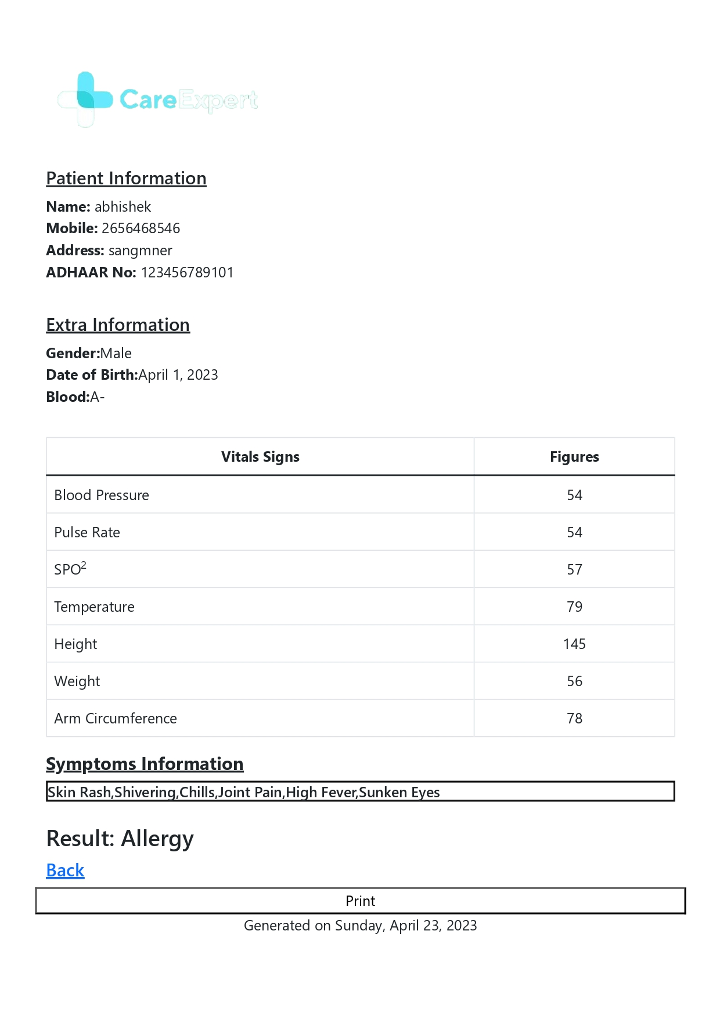

**Report No: 5**

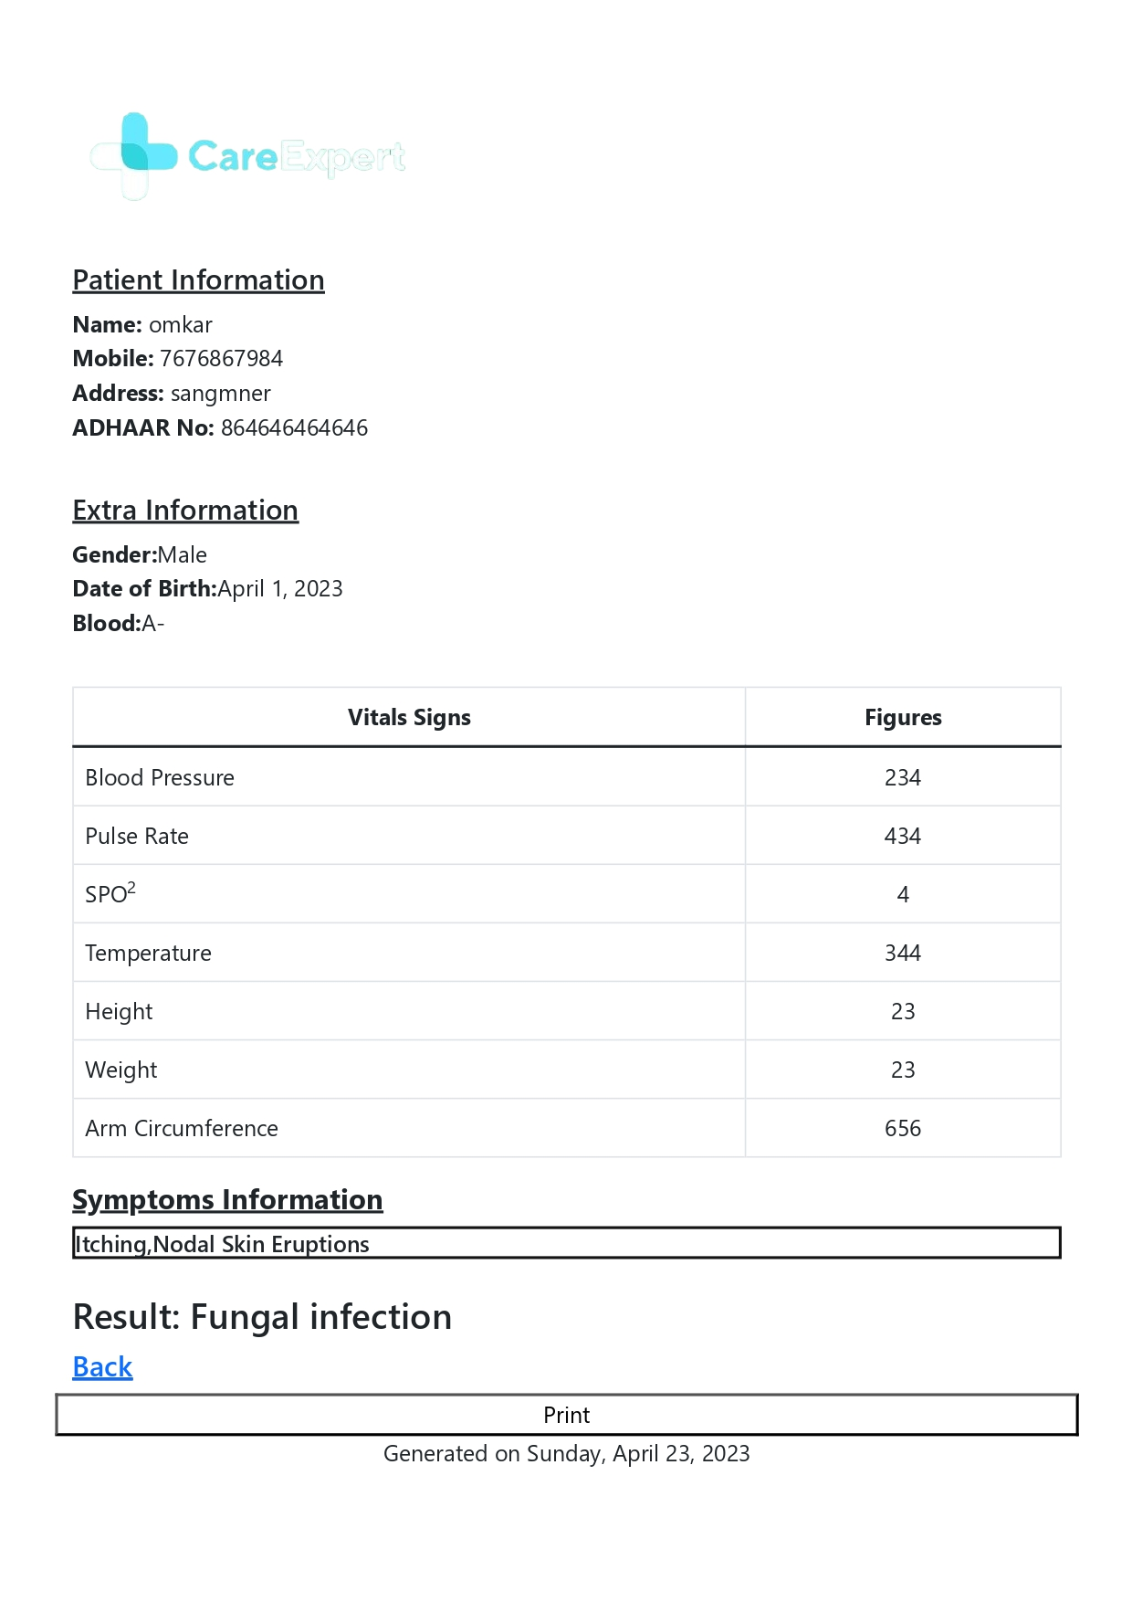

**Report No: 6**

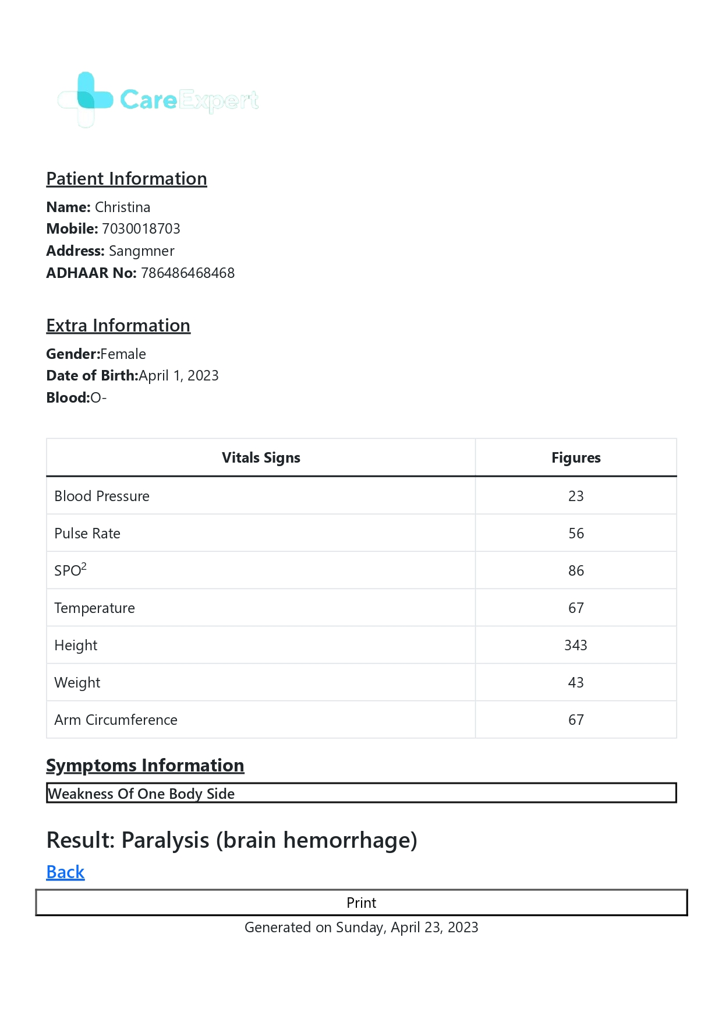

**Report No: 6**

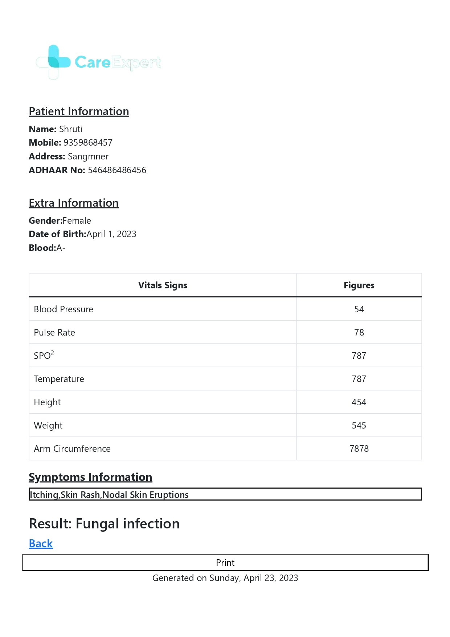

**FUTURE ENHANCEMENT**

CareExpert is a complete healthcare and disease prediction system making heath care and diagnostics simple.

So far now CareExpert is capable of detecting diseases based on the symptoms. The Future Update in CareExpert might include Vitals collection through IOT devices for treating different diseases that will eliminate human error and also be time efficient.

Example, Eko is EMR device that can take EMR and generate reports simultaneously making treatment of heart diseases simpler. Thus data from many more devices can be brought into observation and health diseases prediction and treatment can have drastic change. With this Data Precise prediction of the disease can be made using the vitals and the another critical data collected from the various IOT devices.

This Data Can be Stored into remote servers and can be used when required by using API. This Data would be then processed through the software for the prediction of the disease.

Based on the predicted disease the software would also suggest the best suitable treatment procedure or changes from the steps that were followed before. Based on the predicted disease the software would also suggest the required lab tests and also medications to be done by the patients.

# BIBLIOGRAPHY

* [https://www.geeksforgeeks.org](https://www.geeksforgeeks.org/)
* [https://www.javatpoint.com](https://www.javatpoint.com/)
* <https://www.tutorialspoint.com/index.htm>
* <https://stackoverflow.com/>
* <https://www.udemy.com/course/django-and-python-full-stack-developer-masterclass>